Piia Laine

Project Plan

Blog

Contents

1. Background 2

2. Mission 2

3. Goals 2

4. Restrictions 2

5. Time Restrictions 3

6. Environment 3

7. Work phases 3

8. Front Page Prototype 4

9. Expenses 5

10. Work methods, documentation and informing 5

10.1. Documents 5

10.2. Saving 5

11. Risks and criteria for cancelling 5

11.1. Skill level risks 5

11.2. Equipment risks 5

11.3. Management risks 5

11.4. Cancellation 6

12. Quality 6

# Background

The project, which is to create a blog, will be done as a part of a school course. I plan to make a blog that fits the theme it is going for and my personality.

# Mission

My mission is to create a blog that fits my theme and personality and generally looks good, while challenging myself to learn new ways of programming.

While I’m not entirely certain yet, I plan to create at least part or the whole website using Java.

Alternatively, I might use the JavaScript framework Angular and Angular material design to create a nice and professional looking blog that is very responsive and interactive.

# Goals

The goal of the project is to build a trendy blog with a functioning database. The endpoint of the project is the end report, which will be written after all the parts of the blog have been put together.

By then the site needs to be able to be published.

# Restrictions

As of now, there aren’t any visibly big restrictions, because I’m allowed to design my blog the way I want it, as long as it ends up becoming a complete blog.

However, the personal skill level could pose a problem, but luckily you can find many solutions to code problems online, which will be very helpful in this project.

The biggest obstacle at first will be to decide how exactly to program the website, but this obstacle will also be overcome by searching solutions online and using the programming knowledge I have gained so far.

# Time Restrictions

|  |  |
| --- | --- |
| **Project-Milestone Plan** | |
| ***Milestone*** | ***Date*** |
|
| **Project start** | **03.06.2019** |
| Design Prototype (Frontpage) | 12.06.2019 |
| Decision to continue with Java: Yes or No? | 17.06.2019 |
| **Blog finished** | **26.07.2019** |
| Presentation | Week 32 |
| Final report | Week 32 |
| **Project End** | **Week 32** |

# Environment

The environment includes the resources and information sources like the internet.

The software that will be used includes the Microsoft office package for documentation and project management and as coding languages I will be using the common web creation languages like PHP, JavaScript and HTML, but I will try to implement as much Java as I can into the project, because I want to try out a new programming language and train my programming knowledge.

The work will primarily be done on Windows computers.

# Work phases

The project will start on 3.6.2019 and will last the summer.

At first, we will have an experimenting stage to see, which tools and programming languages works best, here we will also try to figure out how to implement Java into our project.

If Java turns out to be too big of a challenge, at this phase we can also decide to change that plan, but for now we plan to experiment with Java and get good knowledge on how it works.

On the next phase we will start creating the frontpage and user interface and after that we will start to implement database for the blog entries.

In the end phase we will put all the single parts into a full website.

# Front Page Prototype

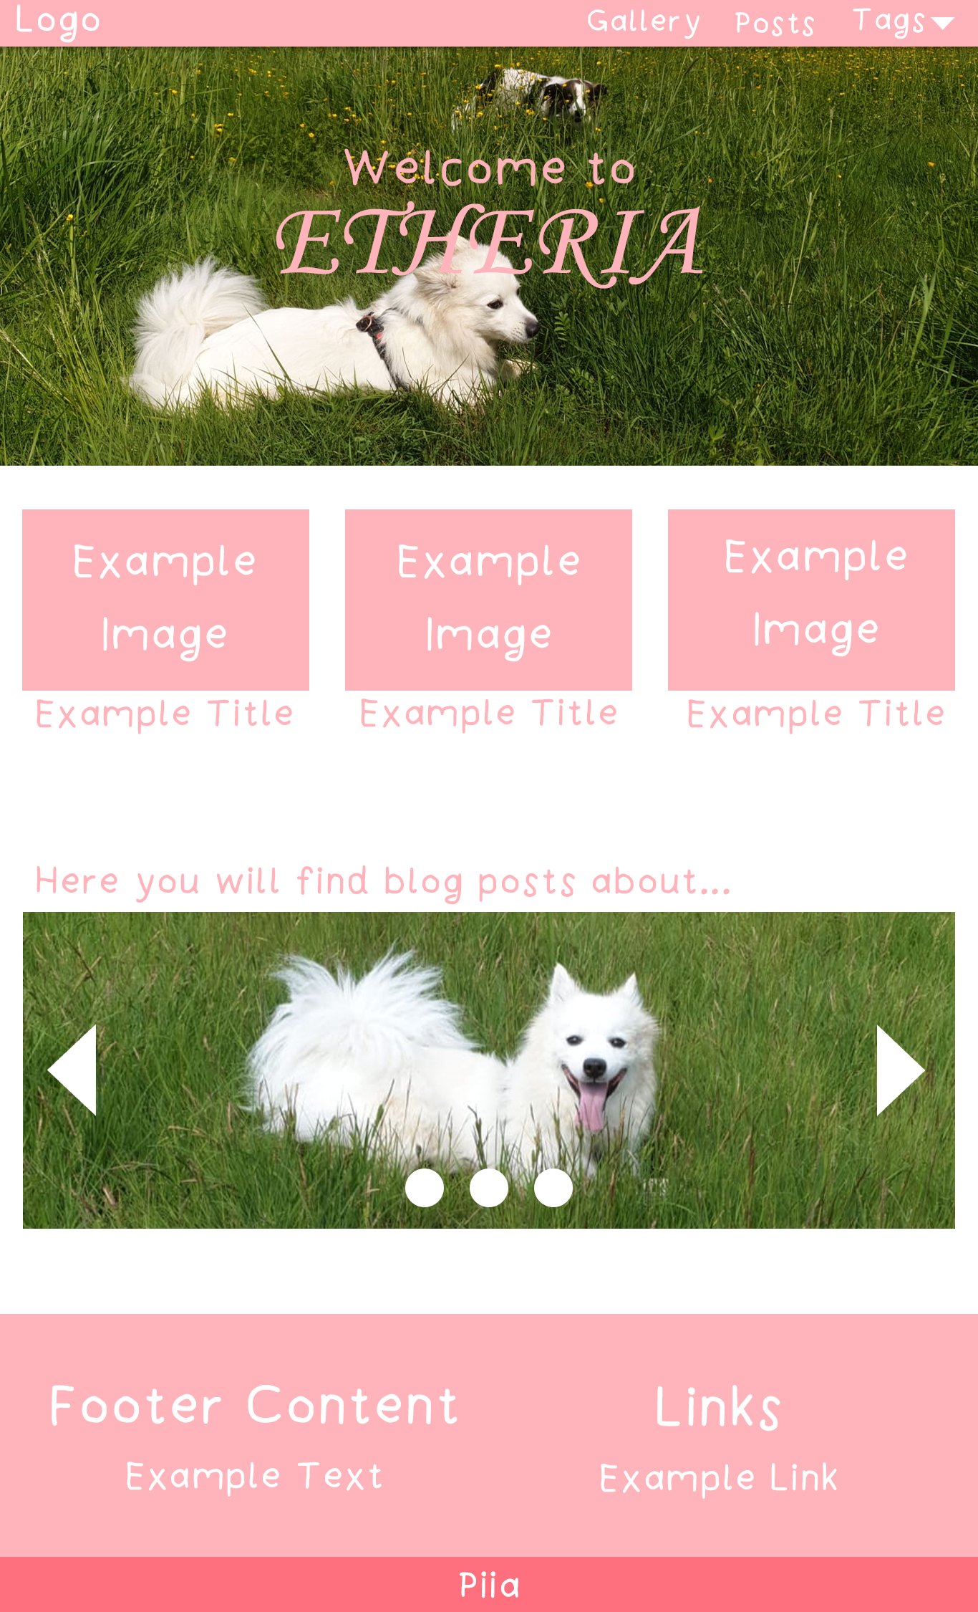

# Expenses

The project might cause expenses, if I decide to buy webspace or because of the database, but if it’s possible, I will definitely try to have no costs at all.

# Work methods, documentation and informing

## Documents

The work is created and stored in electronic form.

The project management is done beforehand, and the project is being documented at every step. Every planned and invested time needs to be recorded inside an excel table.

## Saving

Documents will be saved on my computer and taken with me, when I need the files at school.

# Risks and criteria for cancelling

## Skill level risks

As already described, the skill level could become a risk.

If the skill level is too low, it could hold back the progression of the project, though I know that I am very good at collecting information online and that will help me to prevent the risk of having a too low skill level.

## Equipment risks

Equipment-related risks are non-existent in this project, as this project doesn’t require any heavy equipment that can’t be easily found.

All that is needed is access to the school and their computers and an own computer.

## Management risks

Management risks could be time risks.

If the time is not managed and planned properly, then it could cause time problems later on, but this can be prevented by good planning.

## Cancellation

The project will not be canceled, as it’s needed for school, but whenever problems come up, they should be focused on immediately, so that it doesn’t become an even bigger problem later on.

# Quality

The invested time and plans are documented at all times, as it is essential for success, and regular checkups with the set milestone should keep the project on track.

If possible, I need to seek out feedback from others to see what others think of the blog.